DISTANCE LEARNING – WEEK BEGINNING 29th MARCH 2020
Day | English |  | Maths
Sun 29th | Sunday: Poster  Introduction At the start of the year we learnt all about being healthy and having good hygiene. Remember we did the experiment with the potatoes; we rubbed them on the floor, whiteboard and bins. Also we did a lesson using glitter to show how bacteria and germs spread everywhere.  Key Questions  - What can you remember about germs and bacteria?  - How can have good hygiene?  - What can we do tell people how they can stop germs from spreading?  Task  Today you are going to create a poster all about hand washing.  We know it is very important that we wash our hands so that we do not spread germs and stay clean.  Things your poster can include:  - Add pictures and drawings with lots of colour  - Instructions to tell us to wash our hands and why it is important.  For example: Wash your hands for 20 seconds to keep the germs away.  Have a look at the pictures I have included for some ideas.  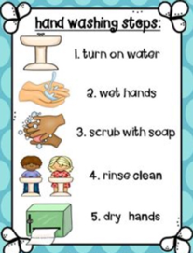  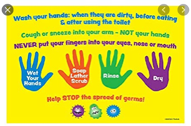  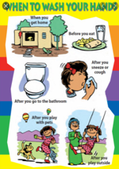  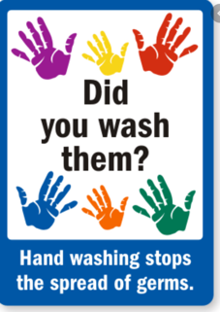 |  | Sunday: Addition  Introduction Today boys and girls, you are going to practice adding. Remember when you add to numbers together the answer is always bigger. For example 4 plus 6 equals 10.  Key Questions  What can we use when we are adding two numbers together?  - Our fingers  - Counting forward  - Our brain – mental maths  - Dienes  - Drawing lines for tens and dots for ones  - Column method  Today will be practising our column method.  Look at the example below 51+ 34. You can see that the larger number is at the top and the smaller number is directly underneath it.  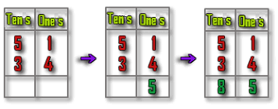  When adding the two numbers together remember you need to add the ones first and then the tens.  Task  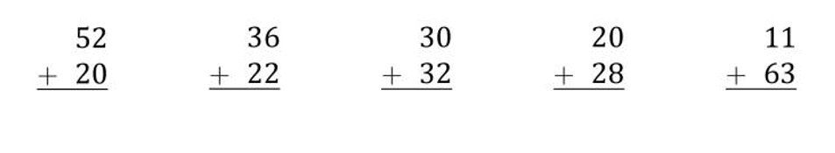  Look at the calculations below and add the two numbers together:  Write these calculations straight into your distance learning book.  ***As a Challenge I would like you to create your own addition calculations for you parents or siblings to complete.
Monday: Nouns  Introduction  Today you are going to learn about nouns. We will learn about and find nouns in a sentence.  Key Questions  - Do you remember what a noun is?  - Can you mention a noun you know before learn about it?  A noun is a type of word; a person, a place, a thing or an object.  For example: A teacher is noun, Dubai is a noun and a ball is a noun.  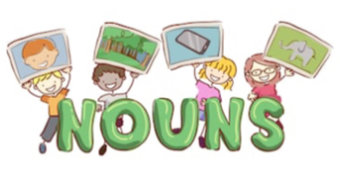  In our writing we use lots of nouns and we describe them. Today you will find out more about the common nouns.  Task  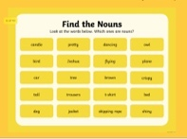  - Your task is to circle the nouns you can find on the table.  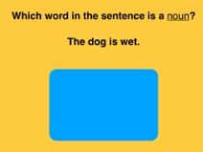  - Say the noun you can find in the sentence.  - Tell people at home all the different nouns you can see in your house.  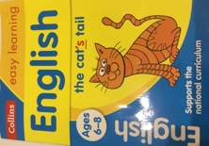  For a challenge, go to your Collins homework English book and complete pages 18 and 19. |  | Monday: Subtraction  Introduction  Yesterday we practised adding two number together. Well done !  Today you are going to practice subtracting. We can also call this ‘taking away’. Remember when you are subtracting numbers and writing the number sentence you must always remember to start with the largest number and take away the smallest number. For example 10 subtract 6 equal 4.  Key Questions  What can we use when we are subtracting two numbers ?  - Our fingers  - Counting back  - Our brain – mental maths  - Dienes  - Drawing lines for tens and dots for ones (crossing out)  - Column method  Today will be practising our column method.  Remember you need to take away the ones first and then the tens.  Let’s look at this one together.  Task  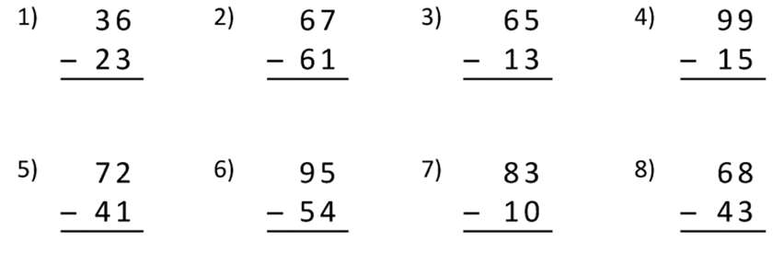  Look at the subtraction calculations below, write and complete them in your distance learning book.
Tuesday: Describe what Goldilocks looks like  Yesterday you learned about nouns – a noun can be a person. Today you are going to describe the character Goldilocks. Most of you should have the book at home so please use this to help you by looking at the pictures of her.  When we are describing a person we write about their eyes, hair and clothes. Maybe you have some more ideas and could include some more interesting descriptions.  In your distance learning book write some of the words you would use to describe what she looks like.  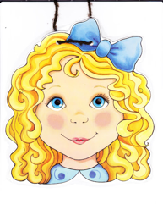  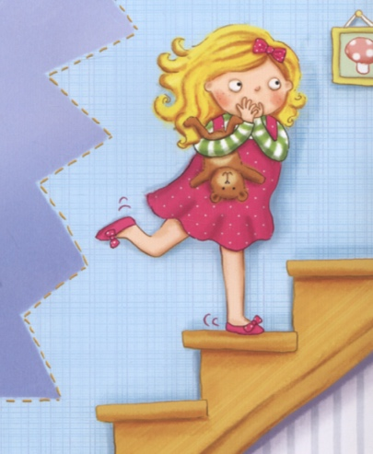 |  | Tuesday: Measuring  Introduction  Today you are going to measure the length of different objects around your house. Remember the length tells you how long or tall an object might be.  Key questions  What can you use to measure the length of objects?  - Ruler or Meter stick  - Hands or Feet  We will be using a ruler to measure. Remember when using a ruler we place the object beside the ruler and start to measure from 0. Count how many centimetres your object is.  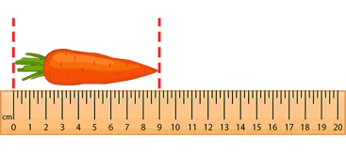  Look at the example below.  This baby carrot is 9cm long.  There are lots of different items that you can find around your house. Here are some examples:  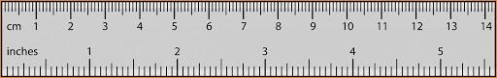  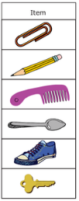  Find a ruler to help you measure your objects.  Remember we use cm to measure smaller objects.  Task  Your task today is to measure objects in your house and record the length.  Send a picture of this to your dojo portfolio.  Extension Task  Draw a line in your distance learning book and measure how long it is.  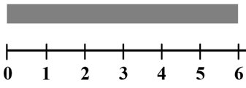  Example: Line = 6cm
Wednesday: Describe the personality of Goldilocks and how she behaves.  Today you are going to think about what Goldilocks did in the story. Is she a nice girl? Is she a naughty girl?  What does Goldilocks do in the story? Write some sentences in your distance learning book describing what she does to the three bears.  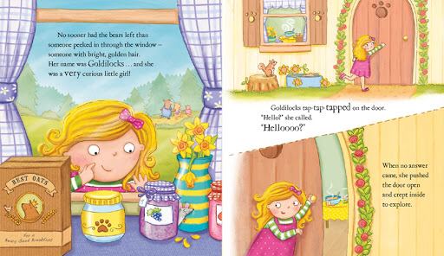 |  | Wednesday: Measuring  Introduction  Today you are going to compare the size of different objects in your house. When we compare the length of objects, we place the objects beside each other and decide which object is the longest and which one is the shortest.  Look at the example below  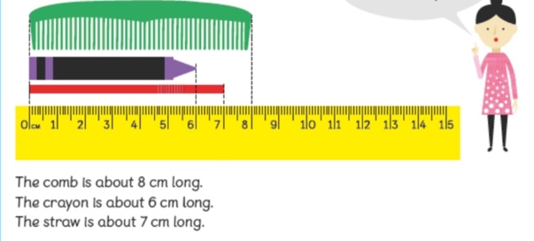  Key Questions  Which object is the longest?  Which object is the shortest?  What can I use to measure small objects?  Task  Pick a selection of your toys/household items and arrange them:  - shortest to tallest  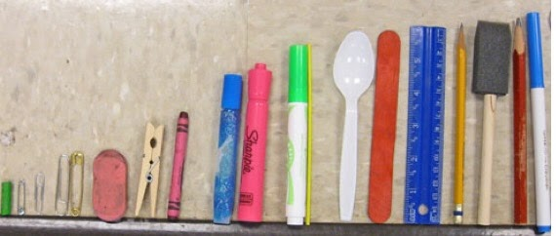  Here is my example.  Extension task  Choose 2 objects and compare the size of these objects.  Example:  Pencil 18cm Crayon 5cm  The pencil is 13cm longer than the crayon because  18 – 5 = 13cm
Thursday: Spelling Practice  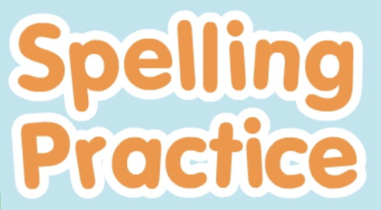  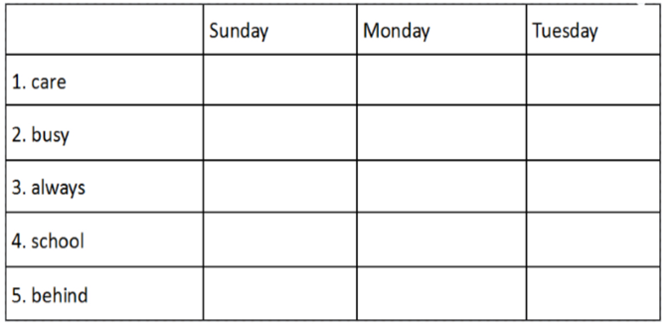  Today you are going to be practice your spelling words. When you practice your spellings you should use the method: Look and say the word, cover the word, write the word and then correct it if you need to. Remember to use your phonics sounds to help you if it is a green word. |  | Thursday: Mental Maths  Today you are going to be adding tens to numbers. Try to count on in tens to help you.  Can you complete within 3 minutes.  